Types of Black-Box Techniques
# Source: AI Source: Provided by: [Data Path: Persons Table -> ID Column: 1, Name_En Column: Motasem Essam] -> From: [ChatGPT] on [8/24/2025]
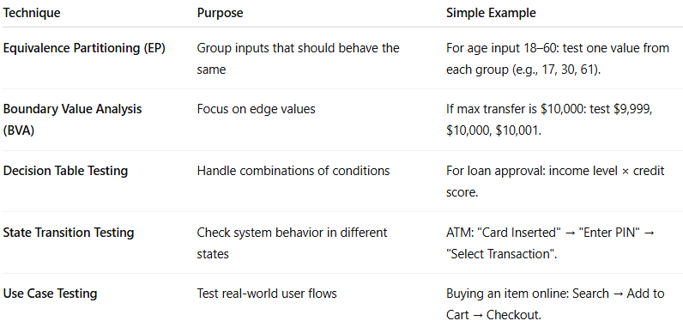
Technique | Purpose | Simple Example
Equivalence Partitioning (EP) | Group inputs that should behave the same | For age input 18–60: test one value from each group (e.g., 17, 30, 61).
Boundary Value Analysis (BVA) | Focus on edge values | If max transfer is $10,000: test $9,999, $10,000, $10,001.
Decision Table Testing | Handle combinations of conditions | For loan approval: income level × credit score.
State Transition Testing | Check system behavior in different states | ATM: "Card Inserted" → "Enter PIN" → "Select Transaction".
Use Case Testing | Test real-world user flows | Buying an item online: Search → Add to Cart → Checkout.

